Logo Analysis

6 steps to evaluate a logo
- Shapes
The shapes you use for your logo are very important. Different shapes mean different things. In addition to the basic shapes, such as circle, square, cross, line and triangle, you can also use more organic forms. The shapes should be adapted in their effect to the company.
- Color
A Logo must be recognizable from the shape at first place, not only from the color. Therefore, it should be designed so that it can also be reproduced and recognized as a monochrome line drawing.
- Font
- has to fit the company
- you still have to be able to read it, even at a small text size

- Explicitness
- Recognizable despite reduction and abstraction
- Don’t arouse false associations
- Don’t raise wrong expectations

- Memorability
- Use only simple and clear shapes
- Differentiate itself from other brands
- Be unmistakable

- Reproducibility
The logo must be able to be used in a variety of media (e.g. stamp, fax, T-shirts) and to be displayed in different sizes: from a pen to a wall.

Logo Types
There are basically three kinds of logos. Font-based logos consist primarily of a type treatment. The logos of IBM, Microsoft and Sony, for instance, use type treatments with a twist that makes them distinctive. Then there are logos that literally illustrate what a company does, such as when a house-painting company uses an illustration of a brush in its logo. And finally, there are abstract graphic symbols—such as Nike's swoosh—that become linked to a company's brand.
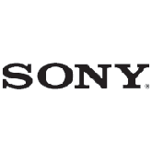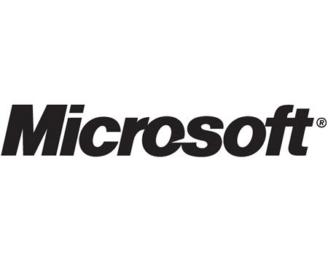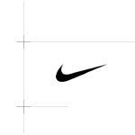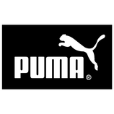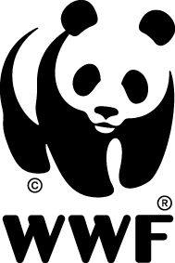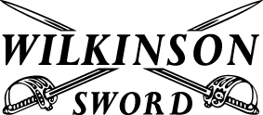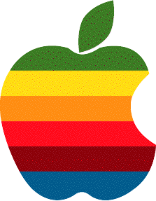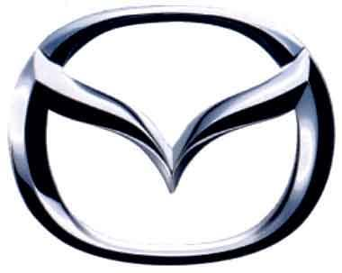

"Such a symbol is meaningless until your company can communicate to consumers what its underlying associations are," says Americus Reed II, a marketing professor at the University of Pennsylvania's Wharton School, who's conducted research on the triggers that lead consumers to identify with and become loyal to a brand. But building that mental bridge takes time and money. The Nike swoosh has no inherent meaning outside of what's been created over the years through savvy marketing efforts that have transformed the logo into an "identity cue" for an athletic lifestyle.
Here are some additional tactics that will help you create an appropriate company logo:
• Look at the logos of other businesses in your industry. Do your competitors use solid, conservative images, or flashy graphics and type? Think about how you want to differentiate your logo from those of your competition.
• Focus on your message. Decide what you want to communicate about your company. Does it have a distinct personality—serious or lighthearted? What makes it unique in relation to your competition? What's the nature of your current target audience? These elements should play an important role in the overall design or redesign.
• Make it clean and functional. Your logo should work as well on a business card as on the side of a truck. A good logo should be scalable, easy to reproduce, memorable and distinctive. Icons are better than photographs, which may be indecipherable if enlarged or reduced significantly. And be sure to create a logo that can be reproduced in black and white so that it can be faxed, photocopied or used in a black-and-white ad as effectively as in color.
• Your business name will affect your logo design. If your business name is "D.C. Jewelers," you may wish to use a classy, serif font to accent the letters (especially if your name features initials). For a company called "Lightning Bolt Printing," the logo might feature some creative implementation of—you guessed it—a lightning bolt.
• Use your logo to illustrate your business's key benefit. The best logos make an immediate statement with a picture or illustration, not words. The "Lightning Bolt Printing" logo, for example, may need to convey the business benefit of "ultra-fast, guaranteed printing services." The lightning bolt image could be manipulated to suggest speed and assurance.
• Don't use clip art. However tempting it may be, clip art can be copied too easily. Not only will original art make a more impressive statement about your company, but it'll set your business apart from others.
• Avoid trendy looks.

